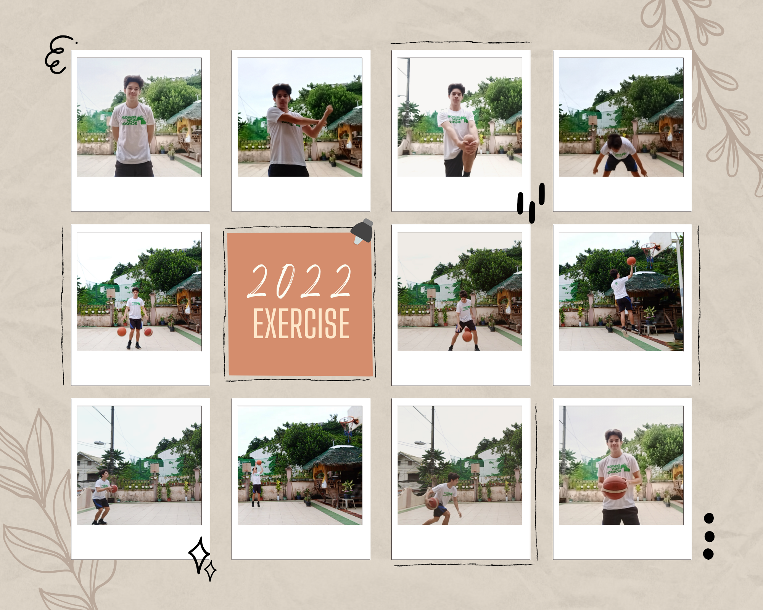

REFLECTION

I always enjoy playing basketball. I’ve played basketball ever since I was young and I’ve kept at it as a hobby. I usually participate in tournaments within Cebu together with my friends throughout the year. Usually when I play basketball at home, I practice and get my routine in. Shooting all over the area and also performing drills to keep improving my skills.

Aside from basketball, I also exercise (but usually I don’t do warmups or cooldowns). I also follow a certain routine when doing my exercises. I usually focus my exercise on core strength and stamina, balance, and also speed. Overall, I think my exercise routine is well-rounded especially for my purpose. I made my routine over the pandemic since I realized I was being so idle and sedentary.

I always enjoy physical activity especially now that I am a Computer Science student – I appreciate it more because it’s my time away from the computer screen and it helps me manage and balance my life out.